UNIT-II
Observation:
Solution of Algebraic and Transcendental Equations
Algebraic Equation
Definition: An algebraic equation is an equation formed using only algebraic operations on the variable(s):
- addition
- subtraction
- multiplication
- division
- raising to a rational power (including whole-number powers)
Examples:
- $x+5=12$
- $2x^{2}-3x+1=0$
- $\sqrt{x}+4=10$
- $\frac{1}{x}+7=9$
All these involve algebraic operations only.
# Applications of Algebraic equations
1.Engineering Design:
1.Used to calculate:
- Beam strength
- Structural stability
- Electrical circuit currents (Ohm’s law leads to algebraic equations)

2. Transcendental Equation:
Definition: A transcendental equation is an equation that involves transcendental functions, such as:
- exponential functions $e^{x}$
- logarithmic functions $ln⁡x,log⁡x$
- trigonometric functions $sin⁡x,cos⁡x$
- Inverse trigonometric functions ${tan⁡}^{-1}x$, etc.
These equations cannot be expressed using only algebraic operations.
Examples:
- $e^{x}=5$
- $ln⁡x+x=4$
- $sin⁡x=x/2$
- $x=cos⁡x$
Because these equations involve transcendental functions, they are transcendental equations.
Applications of Transcendental equations
- R–L and R–C circuits produce exponential equations that contain transcendental function
used in:
- Charging and discharging capacitors
- Signal analysis

The solutions of Transcendental equations can be solved by following methods
1.Bisection Method
Definition: The Bisection Method is a numerical method used to find a root of a continuous equation $f(x)=0$.
It works by:
- Choosing an interval $\left[a , b\right]$where
$f(a)⋅f(b)<0$(i.e., the function changes sign).
- Finding the midpoint
$c=\frac{a+b}{2}$.
- Checking the sign of $f(c)$.
- Replacing either $a$or $b$with $c$to form a smaller interval.
- Repeating until the interval becomes very small.
This guarantees convergence because the function is continuous.
Example of Bisection Method:
Find a root of $f(x)=x^{3}-x-2$between $x=1$and $x=2$.
Step 1: Check signs
$$f(1)=1-1-2=-2 \\ f(2)=8-2-2=4$$
Since
$$f(1)⋅f(2)<0,$$
a root exists in $\left[1 , 2\right]$.
Step 2: Apply bisection
Iteration 1
$$c_{1}=\frac{1+2}{2}=1.5 \\ f(1.5)=3.375-1.5-2=-0.125$$
Now the root lies in $\left[1.5 , 2\right]$.
Iteration 2
$$c_{2}=\frac{1.5+2}{2}=1.75 \\ f(1.75)=5.36-1.75-2=1.61$$

Root lies in $\left[1.5 , 1.75\right]$.
Iteration 3
$$c_{3}=\frac{1.5+1.75}{2}=1.625 \\ f(1.625)=4.29-1.625-2=0.665$$
Root lies in $\left[1.5 , 1.625\right]$.
Iteration 4
$$c_{4}=\frac{1.5+1.625}{2}=1.5625 \\ f(1.5625)=3.81-1.56-2=0.25$$
Root lies in $\left[1.5 , 1.5625\right]$.
Continuing this process, the root approaches:
$$\boxed{x≈1.521}$$
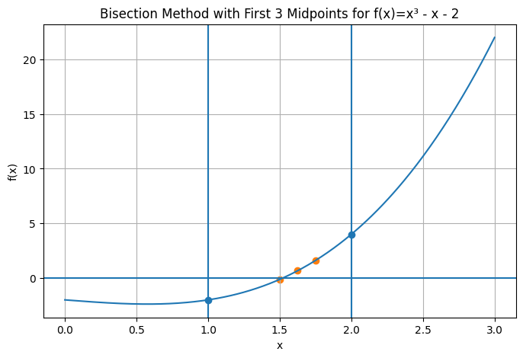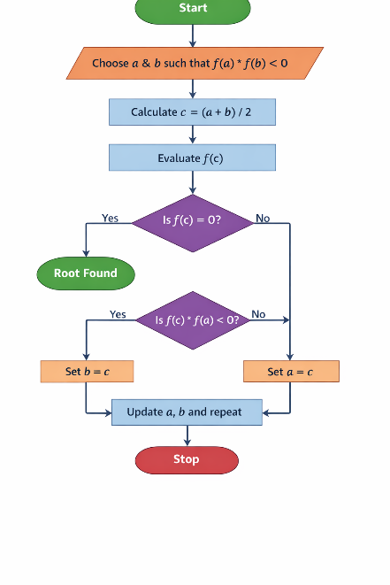

Bisection method
Applications of Bisection Method:
1.Bisection method is used in Engineering Design & Analysis to solve equations that cannot be solved analytically.
Examples:
- determining stress/strain intersection points
- solving beam deflection equations
- optimizing structural parameters
- fluid flow calculations

Record:

3.Experiment : Root of a given Equation using Bisection method Aim: To find the root of given algebraic equation using the Bisection.

Algorithm:
  - Define the function f(x).
  - Choose initial values aaa and b such that f(a)⋅f(b)<0.
  - Compute the midpoint c=(a+b)/2.
  - Check the sign of f(c).
  - Select the subinterval where the sign changes.
  - Repeat steps 3–5 until required accuracy is reached.
  - Display the root.

Find the root of the equation: f(x)=x3-x-1=0 in the interval [1,2]

FLOWCHART:-
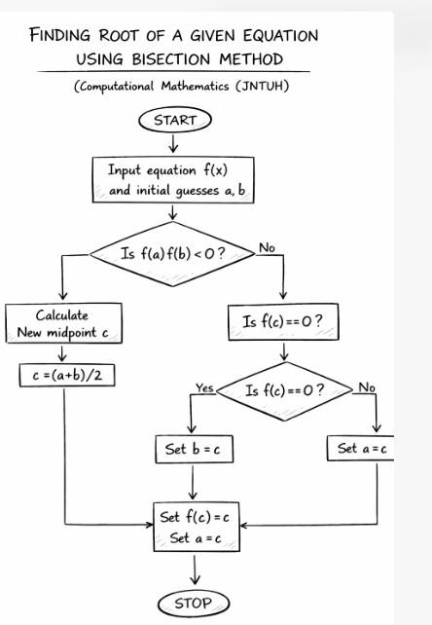

Write program python Bisection Method
# Bisection Method Program def f(x):
return x**3 - x-1 # Initial interval
a = 1.0
b = 2.0

tolerance =0.0001 if f(a) * f(b) >0:
print("Bisection method fails.")
else:
while (b - a) / 2 > tolerance:
c = (a +b)/2
if f(c) == 0:
break
elif f(a)*f(c)<0:
b = c
else:
a = c

print("Root of the equation is:", (a + b) / 2)

Output:
Root of the equation is: 1.375
Root of the equation is: 1.34375
Root of the equation is: 1.32421875
Root of the equation is: 1.326171875
Root of the equation is: 1.324951171875

